AI Assignment 2
Brian Moyles – 21333461

Overview
The purpose of this assignment is to implement a genetic algorithm to evolve strategies for playing the Iterated Prisoner’s Dilemma (IPD). I will be implementing this in Golang, my preferred choice of coding language, and I will look to implement whatever functionality I can from Assignment 1.

Part 1: Evolution Against Fixed Strategies
Fixed Strategies
The fixed strategies used are:
Always Cooperate: The opponent will always choose to cooperate, regardless on player history
Always Defect: The opponent will always choose to defect, regardless on player history
Tit-For-Tat: The opponent will cooperate at the start and will then mirror the previous move of the player
Grim Trigger: The opponent will cooperate, but if the player defects, the opponent will permanently defect
Evolutionary Algorithm
I implemented the genetic algorithm to evolve the strategies over multiple generations. The components of the algorithm include:
Population Initialization
Generates a population of individuals of a size determined by a variable which can be set. Each individual is randomly given one of the 4 fixed strategies to play.
Fitness Evaluation
Each Individual will compete against the fixed strategies for multiple rounds and will get a score based on the performance.
Crossover & Mutation
Traits from parents are combined to produce a child through crossover, while mutation with a rate of 10% introduces diversity to attempt to prevent convergence. These are both used in attempt to produce a better next generation.
Tournament Selection
Like Assignment 1, tournament selection is used to choose the best individuals from a generation and use them as parents for the next generation.
Analysis
To determine if my algorithm worked, I performed testing based on the game-theory logic of self-interest: The player would look to maximize their own gains every run. For example, if the opponent always cooperates, then the player would learn to always defect, in order to get the highest score.
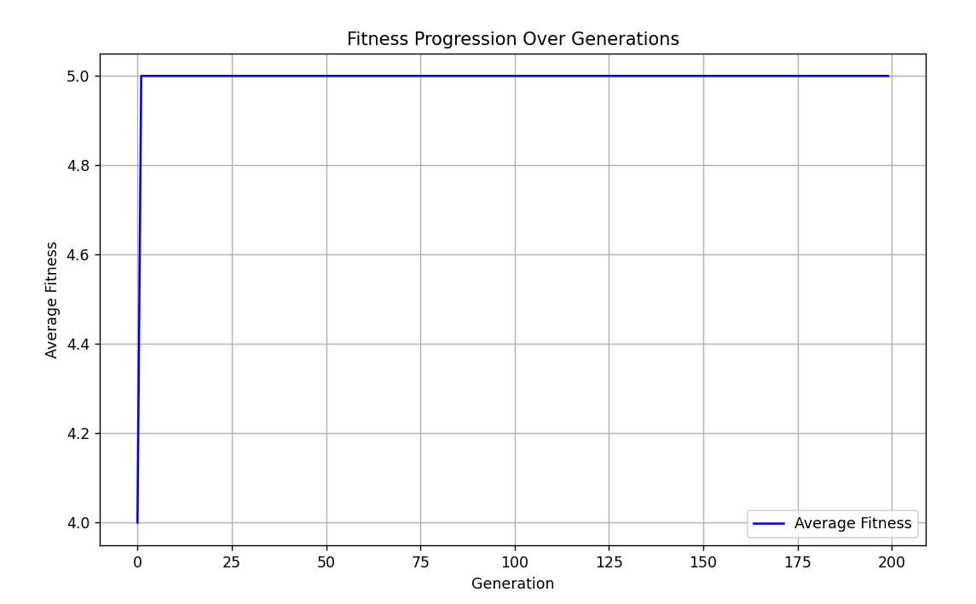
Opponent Always Cooperate
The above graph shows that the player successfully learns to always defect when the opponent always cooperates, maximizing their own score. This is proven for all different fixed strategies, as seen below.
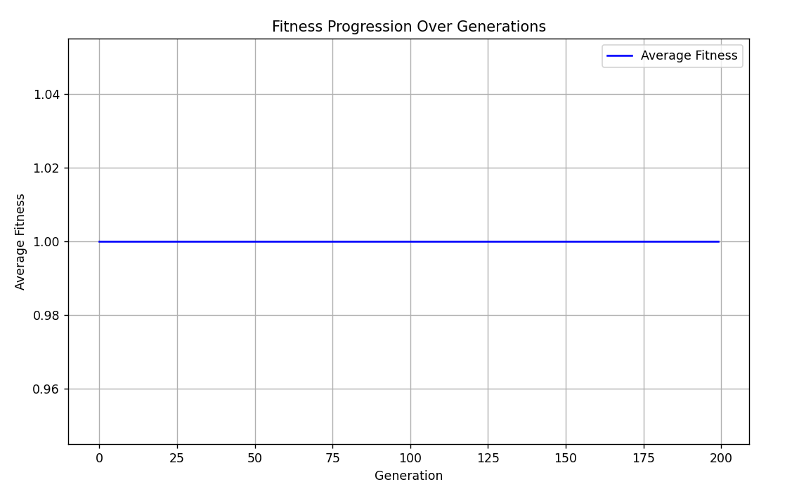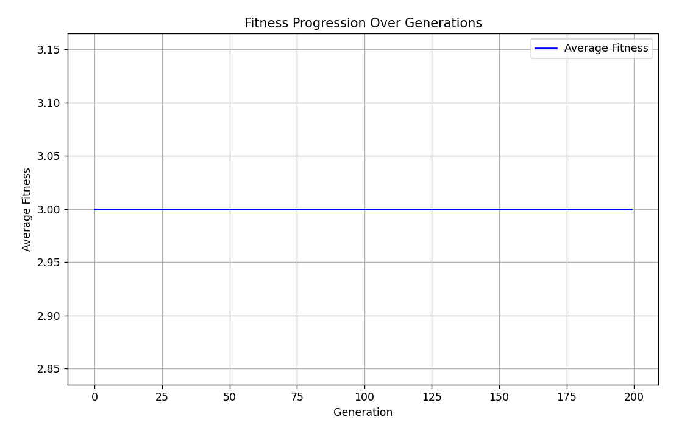
Maximized Gains for (Figure 1: Opponent Always Defects) (Figure 2: Tit-For-Tat)
After proving the algorithm successfully works, it was run with randomized strategies over 200 generations to determine how it performs. This is done to determine how the population adapts when the strategies are not predetermined.
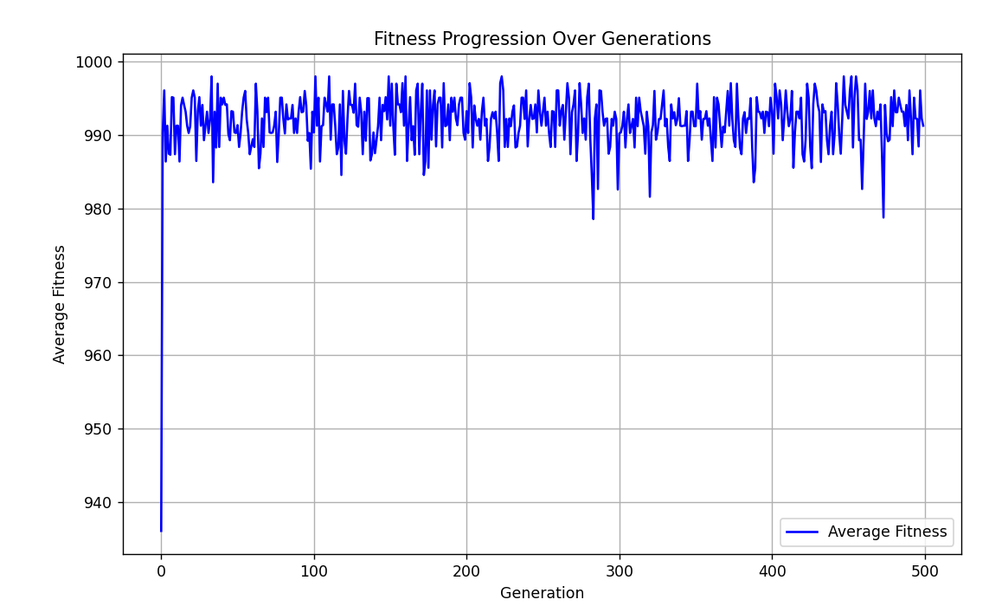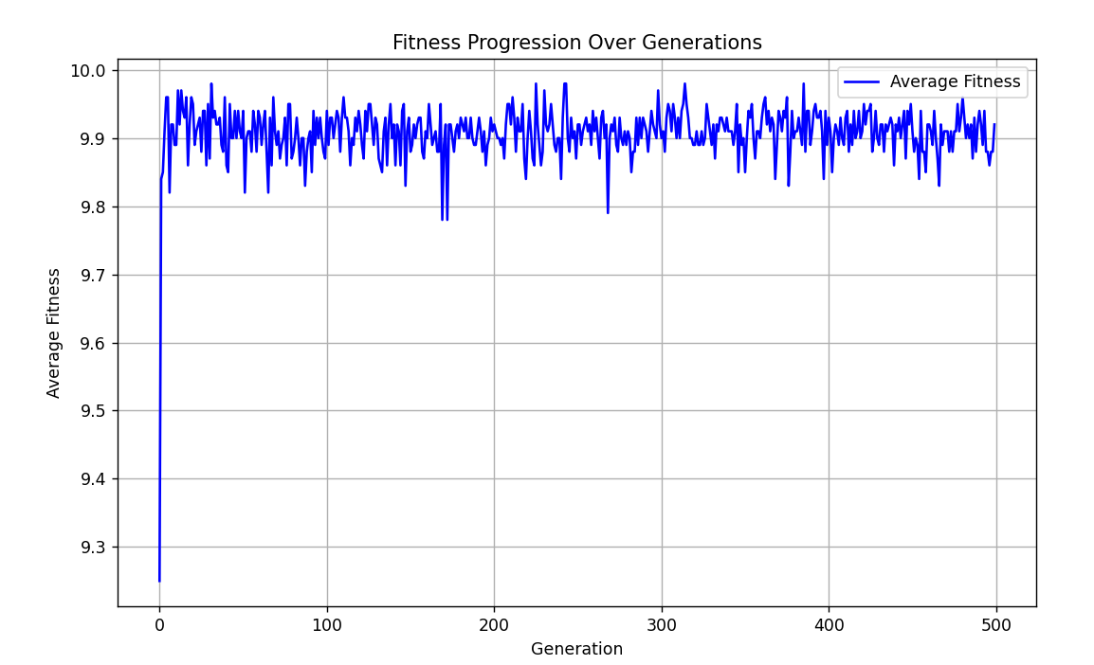
Figure 1: Score Over Generations | Figure 2: (Score Over Generations / Number of Rounds)
The Average Fitness scores seen in Figure 2 show the scores range mostly between 9.8 and 10.0. These scores indicate that the population is dominated by cooperation strategies such as tit-for-tat and Grim Trigger, as these strategies tend to accumulate higher scores (10). The results show that the algorithm accurately calculates fitness, and implements a genetic algorithm for the Iterated Prisoner’s Dilemma

Part 2: Extension

